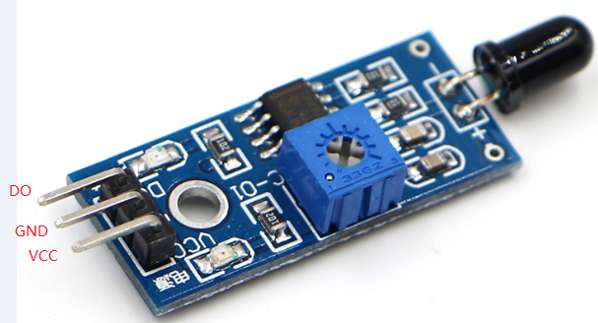

Flame module arduinocontroller
DO 3
GND GND
Vcc 5v

